Kubernetes Documentation

Q1) **Scenario-1: Sample web application with configmap**

1. Deploy a nginx deployment with name web1 and custom index.html. Expose it to nodeport of 30080 in “web” namespace for this scenario.   
   Hint: Use configmap to add custom content to nginx deployment.

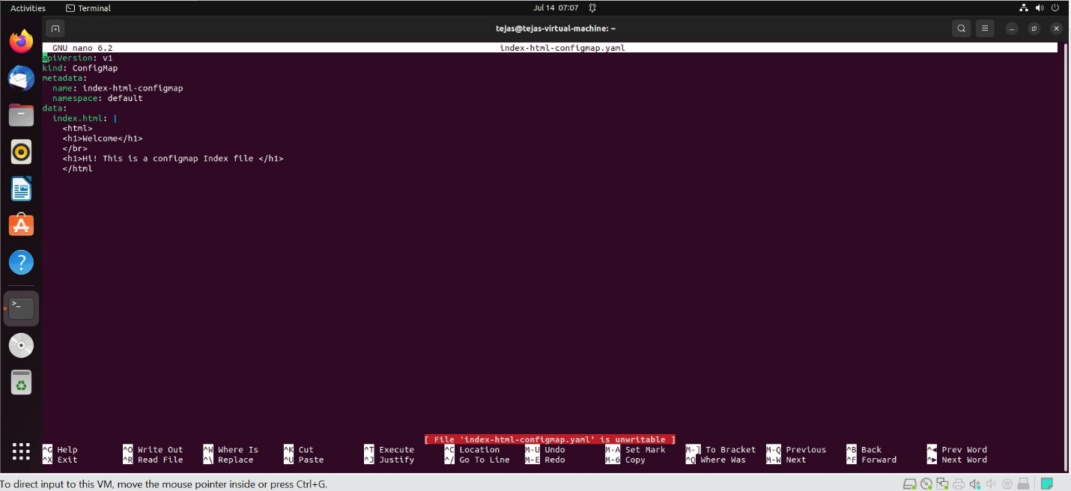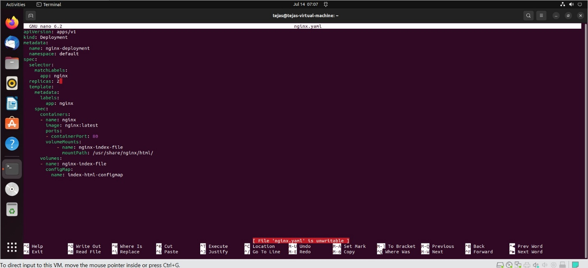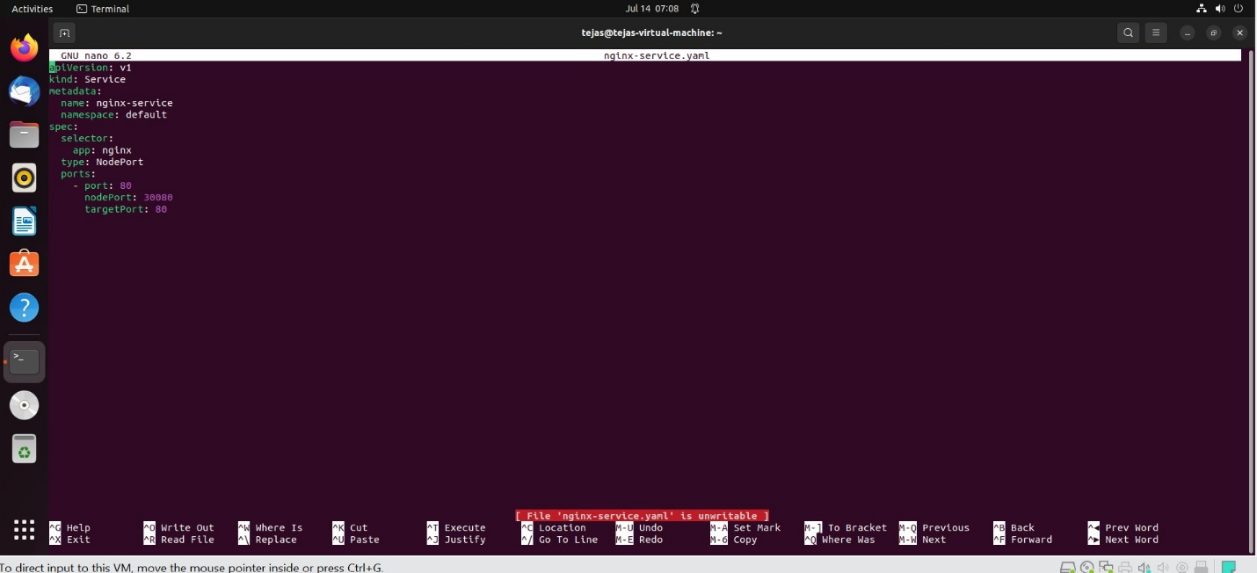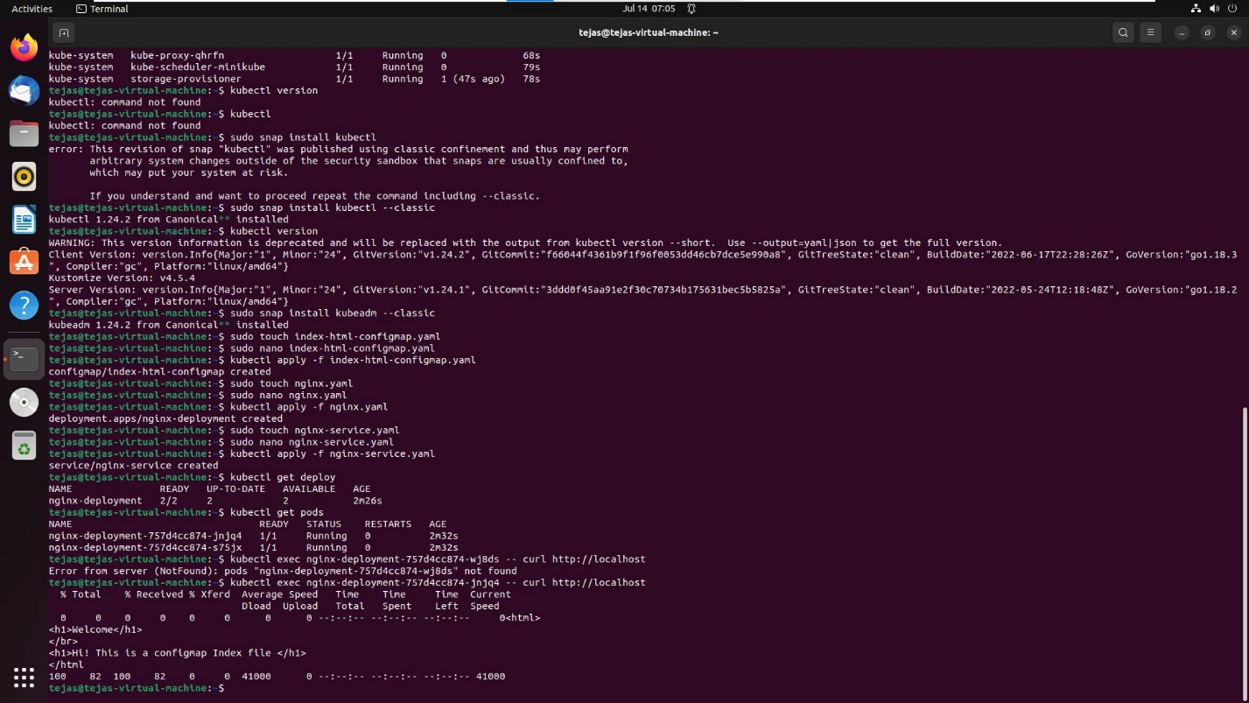

Q2)

**Scenario-2: PV, PVC, secrets**

1. Create a wordpress deployment with mysql as a database and expose it to nodeport 30081. Use “volume” namespace for this scenario and login to wordpress with predefined credentials.   
   Hint: Use PV, PVC, secrets for storing mysql credentials

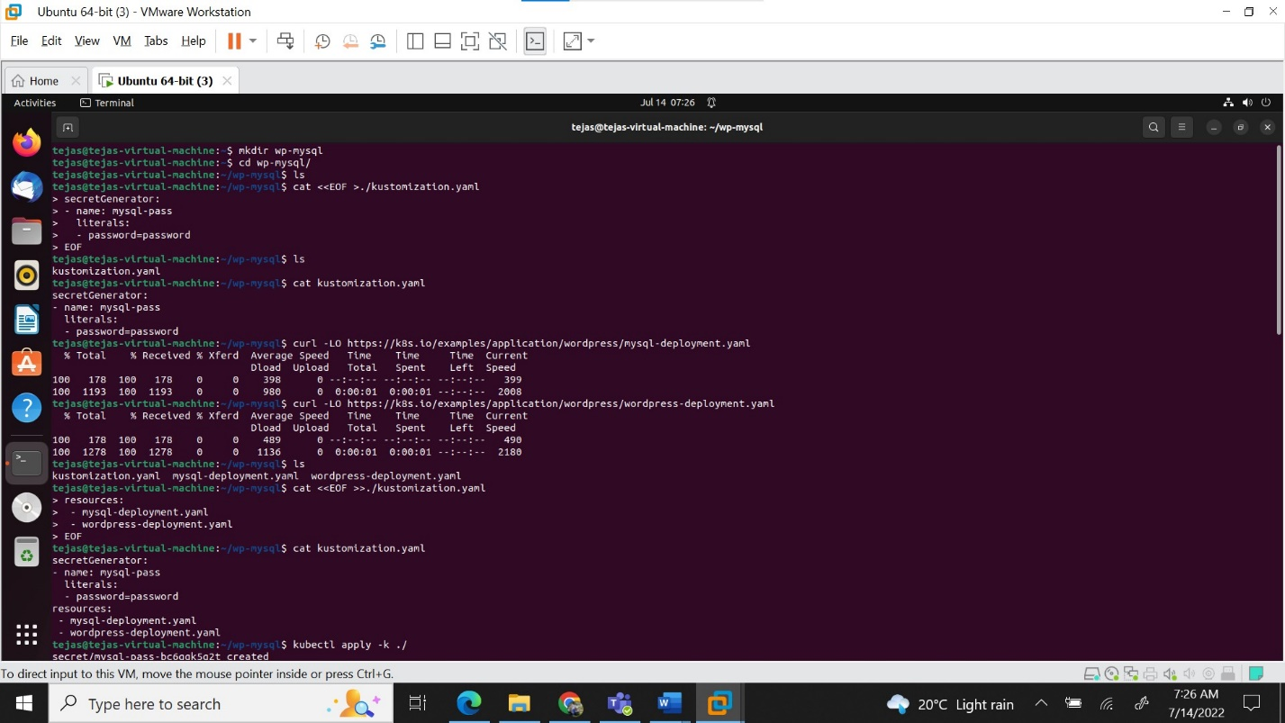

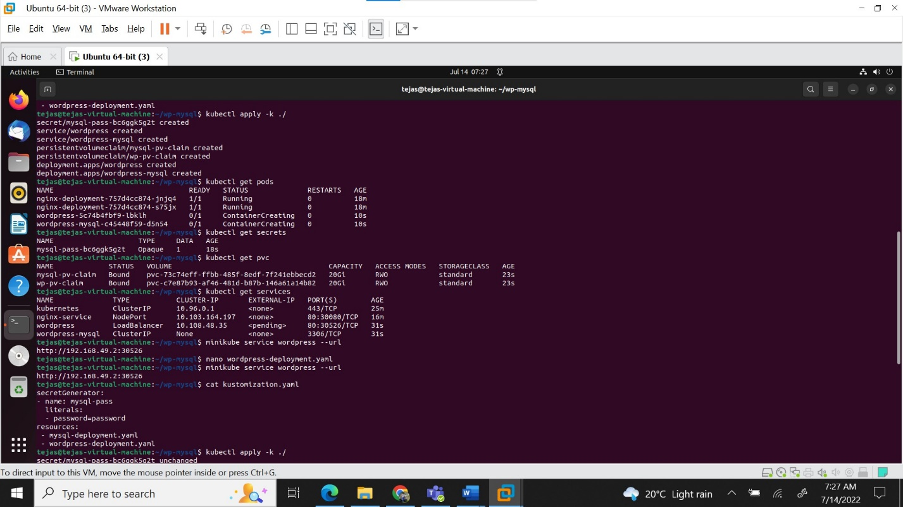

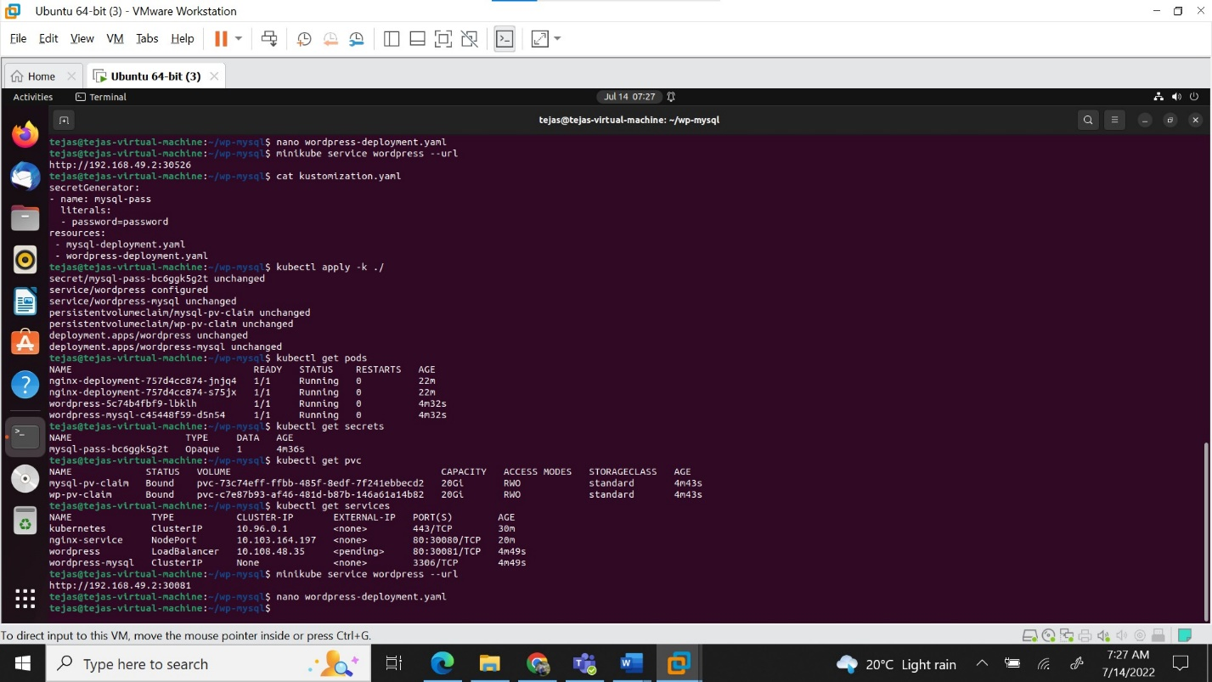

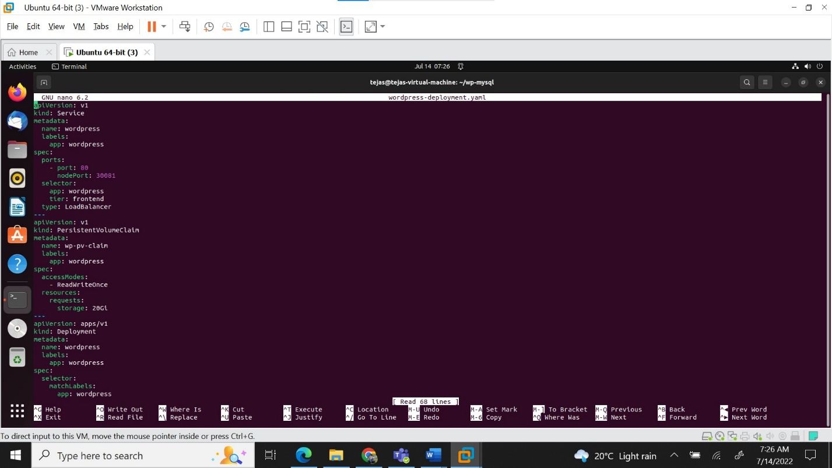

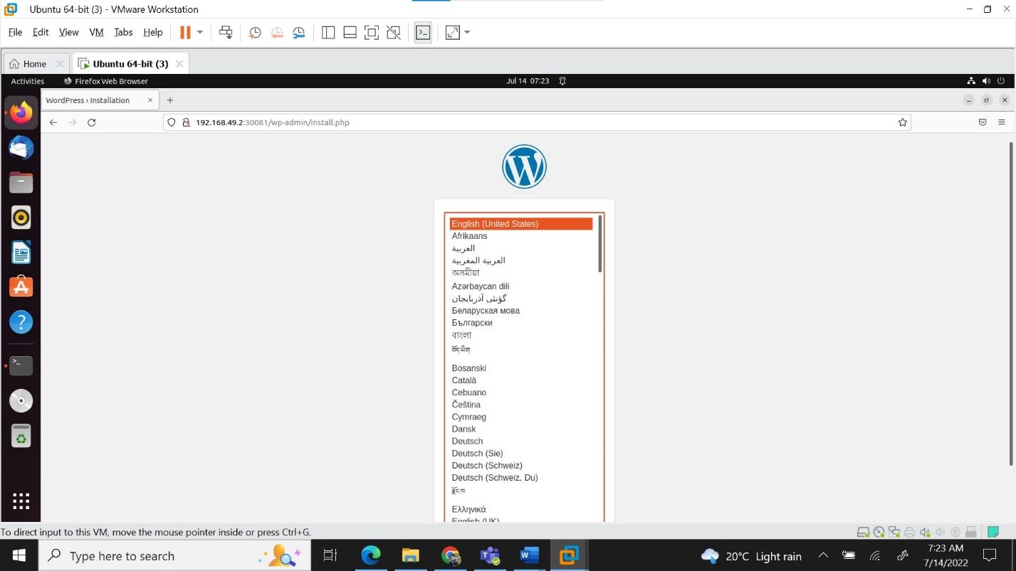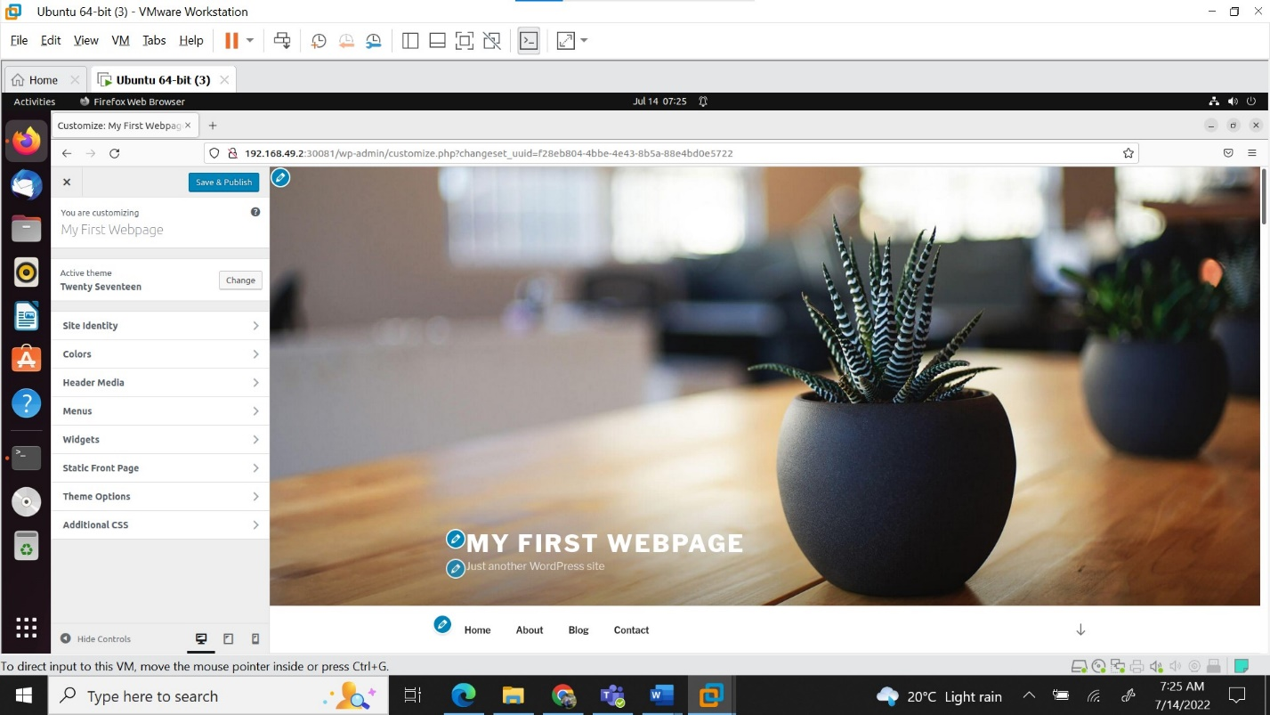

**Scenaio-3: Multi container pod and logging**

1. Create a pod named sidecar with 2 containers named main and sidecar respectively. Fetch the logs from app container to sidecar container. Use nginx for main and busybox:1.28 image for sidecar container. Use namespace sidecar for this scenario.

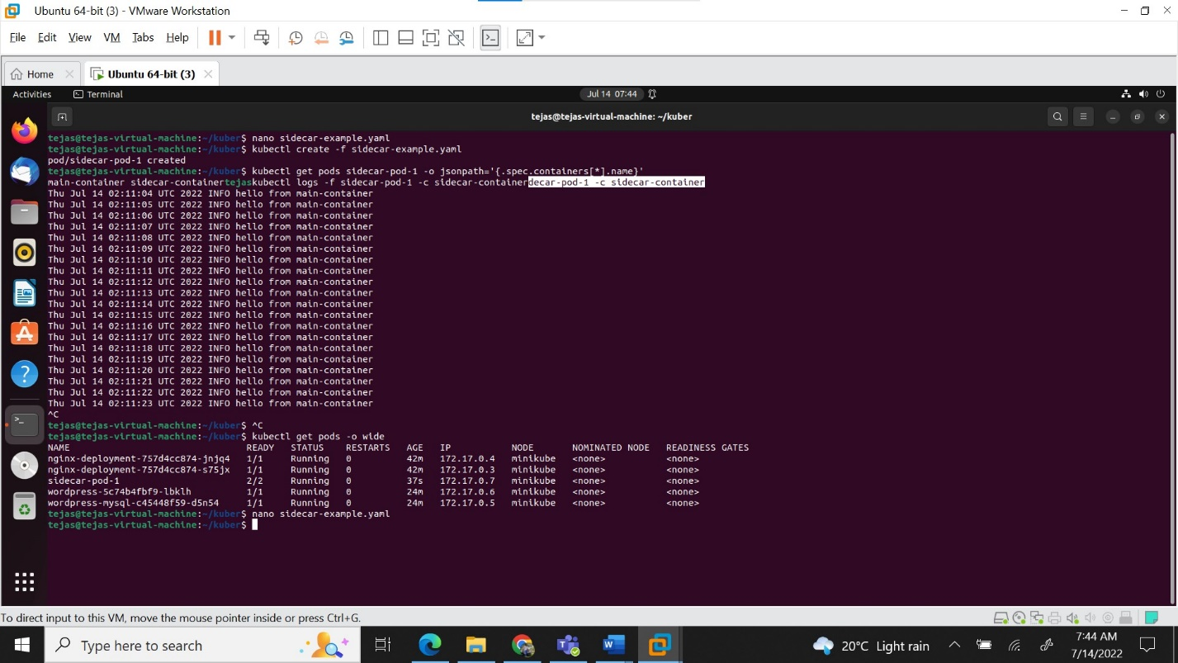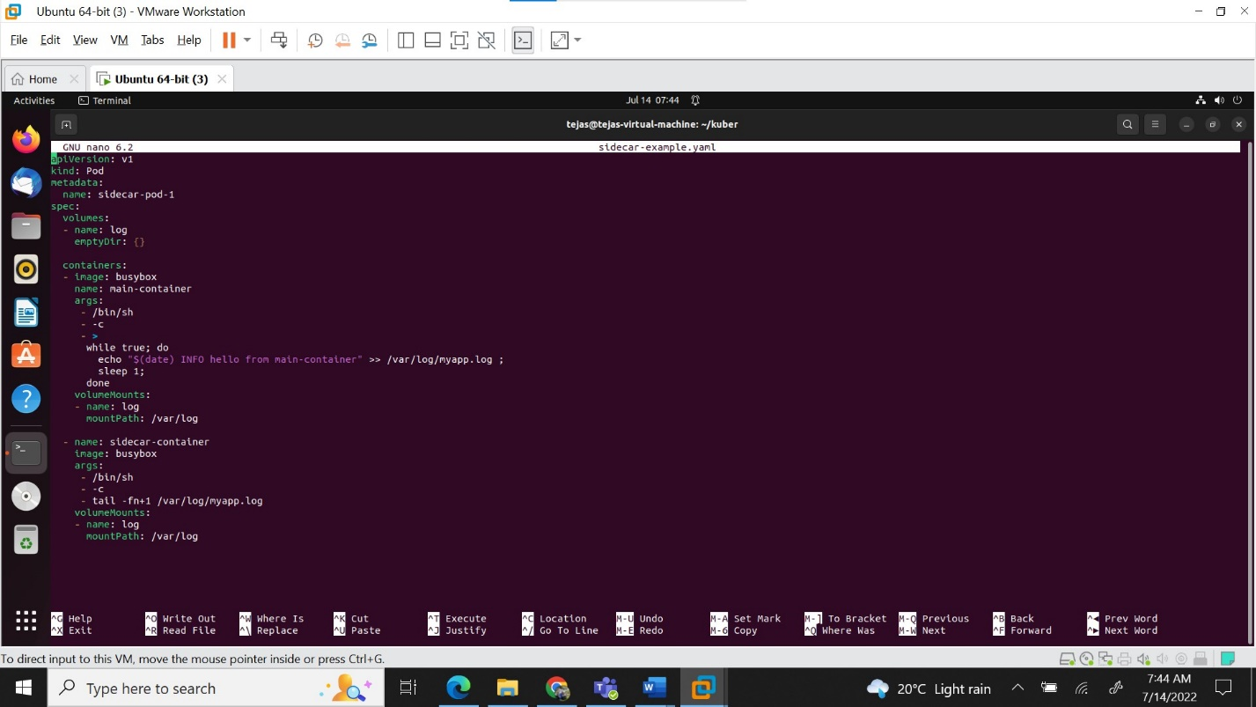

**Scenario-4: Network Policies**

1. Create deployments named web2 and app2 in web and app namespaces respectively. Allow ingress traffic to app2 from web2 and deny traffic from other namespaces and pods. Use nginx image for both the deployments.   
   Hint: Use network policies for this scenario and test it from other pods and namespaces.

